# NA00539_SoCal Public Relations

#### Contact: Rebecca Grose

**619.334.7164 ⬩** [**socalpublicrelations@yahoo.com**](mailto:socalpublicrelations@yahoo.com) **⬩ www.SoCalPR.net**

**FOR IMMEDIATE RELEASE**

**Kirkus Reviews, Starred Review:** “Maysonet’s…prose is unflinching as it illuminates one girl’s traumatic experience with deeply felt compassion and brutal honesty…gilded with resilience and hope. An important book about endings, beginnings and the choice to move on.”

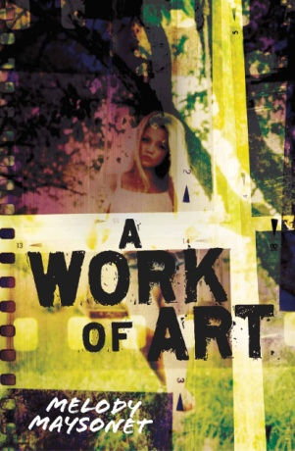

**A WORK OF ART**

**Melody Maysonet**

***What if the one who should protect you***

***is the one who betrays you most of all?***

Tera is seventeen, shy, and artistically gifted. Her hero and mentor is her father, a famous graphic artist who also protects her from her depressed, overly critical mother. Tera can't wait to attend a prestigious art school in France to prove to her artist father, and herself, that she can make it big. But when police arrest her dad for an unspeakable crime, Tera's world is turned upside down and she sacrifices her dream of studying abroad to hire a lawyer. Tera desperately wants to believe his arrest is a mistake, but as her dad's case progresses, she experiences haunting memories that make her wonder: Could he be guilty?

*Mr. Stewart always said that art, in whatever form it takes, is a kind of therapy for creative people. Songwriters compose songs. Poets write poetry. Musicians play music. He said my best artwork was a reflection of things that happened in my personal life.*

*I took my sketchpad to the kitchen table and thought about what Mr. Stewart said—how art was therapy. And then I didn’t allow myself to think. I started sketching....*

Tera’s art becomes a positive force in the midst of horrendous realities, helping her to finally confront the past so she can move toward a future filled with possibilities.

***A WORK OF ART***is a deeply felt and beautifully written story about self-image, self-deception, and the difficulty we all go through when we have to face the whole truth about the myths of our childhoods.

**Melody Maysonet** was born in Alaska but grew up in Illinois. A former English teacher at a community college, she later moved to Seattle, where, under the name Melody Alder, she became editor and columnist for Wizards of the Coast’s *The Duelist* magazine. Then it was off to South Florida, where she began editing, researching, and ghostwriting historical coffee-table books. Currently, Melody is a volunteer teacher at an outreach homeless shelter, but she devotes most of her time to writing fiction for young adults. She lives in Coconut Creek, Florida, with her husband and son. ***A WORK OF ART*** is Melody’s debut novel.

**www.MelodyMaysonet.com**

**A WORK OF ART**

**by Melody Maysonet**

**Edited by Jacquelyn Mitchard ~ Merit Press**

**Available 3.18.15 // Ages 14+**

**$17.99-Hardcover // ISBN: 978-1-4405-8254-7**